1. **Doplň chýbajúce čísla v číselnom rade**

|  |  |  |  |  |  |  |
| --- | --- | --- | --- | --- | --- | --- |
| 0 | 1 |  | 3 |  | 5 |  |

|  |  |  |  |  |  |  |
| --- | --- | --- | --- | --- | --- | --- |
| 6 | 5 |  | 3 |  | 1 |  |

1. **Zapíš počet**

___________ ____________

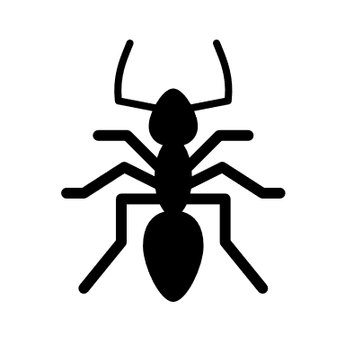__________ __________

____________ _________

1. **Porovnaj < > =**

|  |  |  |
| --- | --- | --- |
| 4 |  | 2 |
| 1 |  | 1 |
| 2 |  | 5 |
| 5 |  | 6 |
| 6 |  | 7 |

|  |  |  |
| --- | --- | --- |
| 4 | Znak ^ smerujúci doprava obrys |  |
| 5 | Znak ^ smerujúci doľava obrys |  |
| 0 | Znak ^ smerujúci doľava obrys |  |
| 1 | Znak ^ smerujúci doprava obrys |  |
| 2 | Znak ^ smerujúci doľava obrys |  |

1. **Zapíš príklady na sčítanie a odčítanie**

 

|  |  |  |  |  |
| --- | --- | --- | --- | --- |
|  |  |  |  |  |



          
          
          