Who would you invite to your video call ?
Interview with Marian Hossa

Why would I invite this fantastic hockey player to my call?

Interview with Marian Hossa I made because I admire him as a sport star and as a man too. As the sport star because he allways played fair, he didn´t start any conflicts and last year he entered to Hall of Fame. As a man, because he’s kind, lovingly kind, and willing to help everyone.

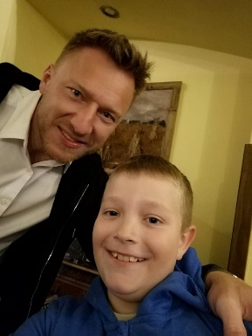
- When did you start playing hockey?
I start playing hockey when I was around 5 years old.

- How did you manage trainings and going to school at the same time?
School allowed me use special plan so I could study and practice.

- What type of student have you been?
I was good average student.

- What team did you play in as a junior?
In Slovakia I played for DUKLA Trencin and in USA for Portland Winterhawks.

- When did get an offer to play in NHL and for what team?
I was drafted by Ottawa Senators so I started play for Canadian capital.

- Was it a difficult decision to leave your parents at such a young age?
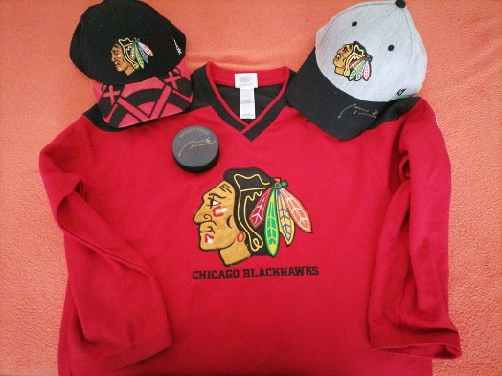
I believe it was more difficult for parents, I was following my goals, so for me it was dream come true

- Which club was your favourite?
Definitely Chicago BLACKHAWKS

- You decided to come back to Slovakia with your family, what are your plans for the future?
I always wanna return home after 20 years in USA. I have many projects I would like to work on and work part time for BLACKHAWKS

- I know you have two daughters; do you watch some of your matches together?
No, only when they google me 😂 but maybe when they are going to be older I believe they are going to watch some of my games.

- What sport are they interested in? (do they like?)
They like Swimming and Gymnastic and skiing so far.
Thank you very much.
You are welcome !

Danny Sopko , 7th A class

